**REACT**

**#5**

**Created a React App named “bloggerapp” in with 3 components.**

1. **Book Details**
2. **Blog Details**
3. **Course Details**

**Implemented this with as many ways possible of Conditional Rendering.**

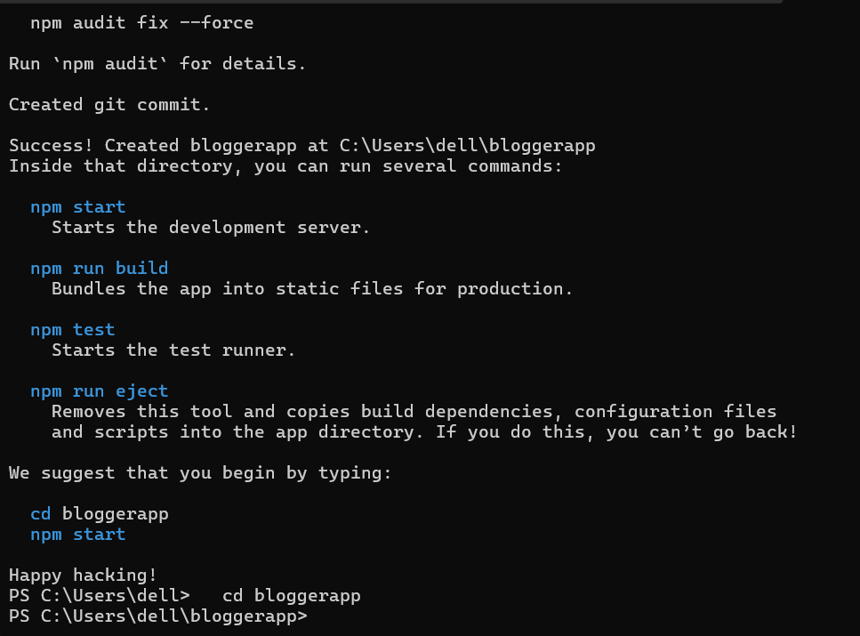

1. **Book Details**

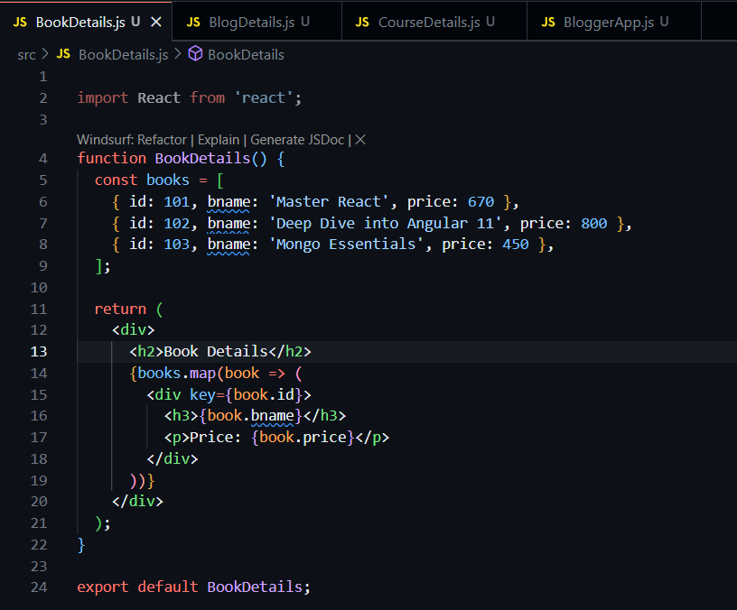

1. **Blog Details**

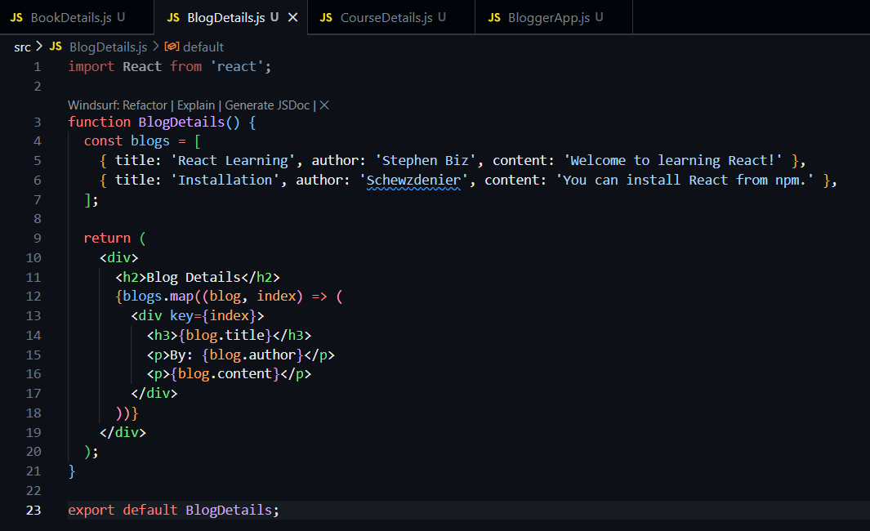

1. **Course Details**

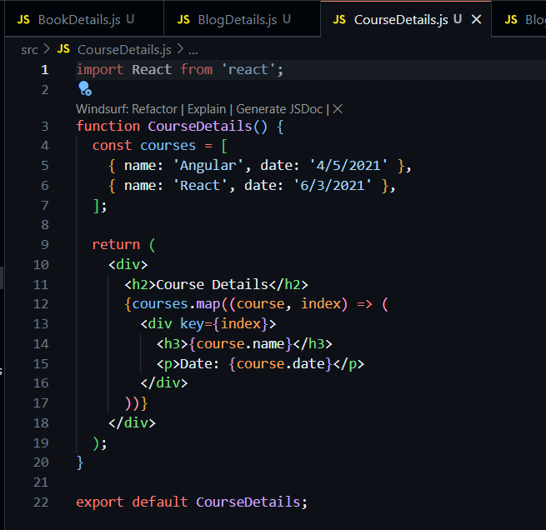

**Implement this with as many ways possible of Conditional Rendering.**

**Method 1: Using If/Else Statements** 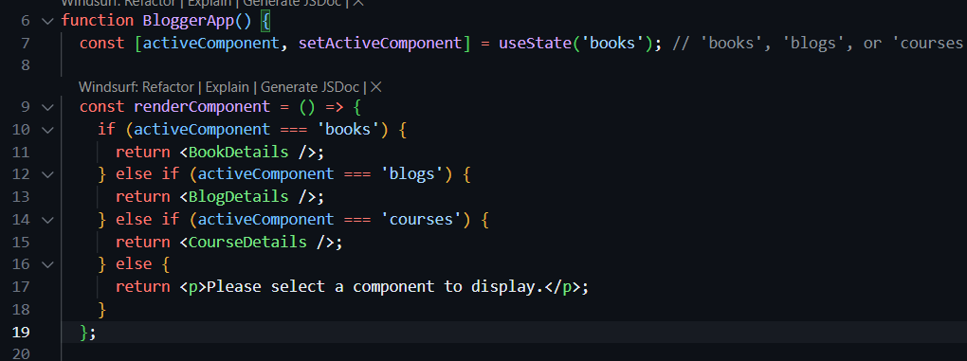

**Method 2: Using the Ternary Operator**

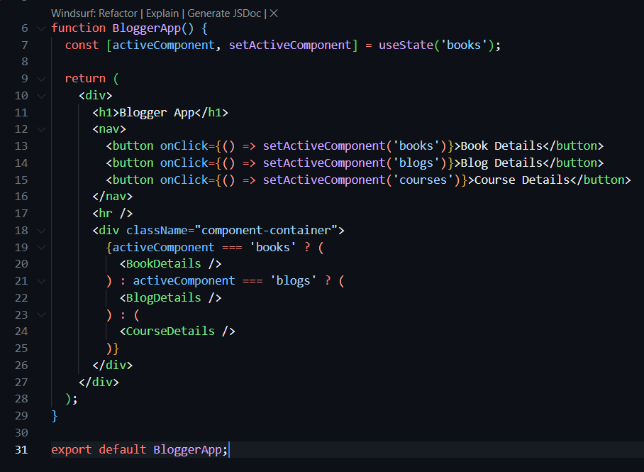

**Method 3: Using the Logical && Operator** 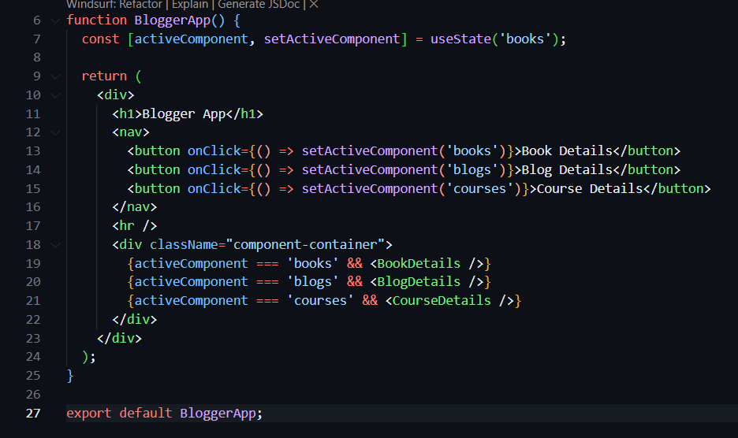

**Method 4: Using a Switch Statement** 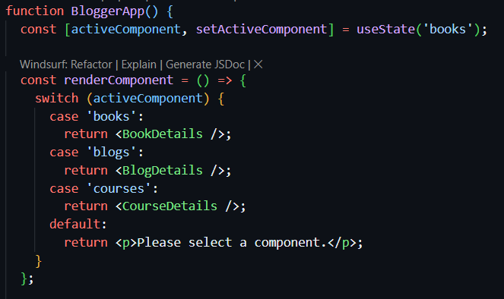

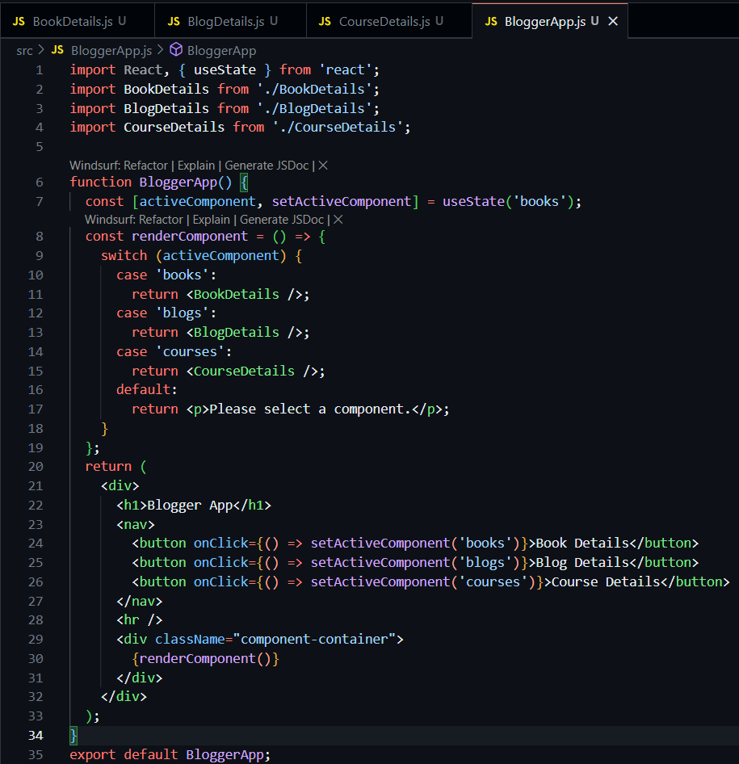

**OUTPUT –**

 